### **MapReduce and PageRank**

**Question 1**:

**Suppose our input data to a map-reduce operation consists of integer values (the keys are not important). The map function takes an integer *i* and produces the list of pairs (*p*,*i*) such that *p* is a prime divisor of *i*. For example, map(12) = [(2,12),(3,12)].**

**The reduce function is addition. That is, reduce(*p*,[*i*1,*i*2,...,*ik*]) is (*p*,*i*1+*i*2+...+*ik*).**

**Compute the output, if the input is the set of integers 15, 21, 24, 30, 49.**

map function:

map (15) = [(3, 15), (5, 15)]

map (21) = [(3, 21), (7, 21)]

map (24) = [(2, 24), (3, 24)]

map (30) = [(2, 30), (3, 30), (5, 30)]

map (49) = [(7, 49)]

reduce function:

reduce (2, 54), reduce (3,90), reduce (5,45), reduce (7, 70)

**Question 2:**

**Consider three Web pages with the following links:**

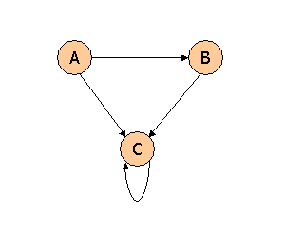

**Suppose we compute PageRank with a β of 0.7, and we introduce the additional constraint that the sum of the PageRanks of the three pages must be 3, to handle the problem that otherwise any multiple of a solution will also be a solution. Compute the PageRanks *a*, *b*, and *c* of the three pages A, B, and C, respectively.**

Value of a, b, or c as we iterate are: a

All PageRank is multiplied by .7 before distribution, and .3 is then added to each new PageRank.

a=β(0)+(1-β)====>0.3

b=β(a/2)+(1-β)===>0.7(a/2)+0.3

c=β(a/2+b+c)+(1-β)===>0.7(a/2+b+c)+0.3

So a=0.3

b=0.7(0.3/2)+0.3==>0.405

c=0.7(0.555+c)+0.3==>c=2.295

Each two variables

a+b=0.705

b+c=2.7

a+c=2.595

**Question 3**:

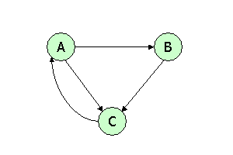

**Suppose we compute PageRank with β=0.85. Write the equations for the PageRanks *a*, *b*, and *c* of the three pages A, B, and C, respectively.**

Given β=0.85

a=β*c+(1-β)1/3

b=β*a/2+(1-β)1/3

c=β*((a/2)+b)+(1-β)1/3

a = 0.85*c + (1 - 0.85)1/3==> a = 0.85c + 0.05

b = 0.85*0.5*a + 0.05, b = 0.425a + 0.05

c = 0.85*[0.5*a + b] + 0.05, c = 0.425a + 0.85b +0.05

**Question 4**:



**Assuming no "taxation," compute the PageRanks *a*, *b*, and *c* of the three pages A, B, and C, using iteration, starting with the "0th" iteration where all three pages have rank *a = b = c* = 1. Compute as far as the 5th iteration, and also determine what the PageRanks are in the limit.**

a = c ,b = a/2 ,c = a/2+b

At 0th iteration: a = 1,b = 1; c = 1

At 1st iteration: a = c = 1, b =1/2,c=1+1/2==>3/2

At 2nd iteration: a = c =3/2,b=a/2==>1/2,c=1/2+1/2==>1

At 3rd iteration: a = c = 1, b = a/2=3/2*2==>3/4,c=3/4+1/2==>5/4

At 4th iteration: a = c =5/4 ,b=a/2=1/2,c=5/4

At 5th iteration: a =5/4,b=5/8,c=9/8